**DAILY ONLINE ACTIVITIES SUMMARY**

|  |  |  |  |  |  |  |  |  |
| --- | --- | --- | --- | --- | --- | --- | --- | --- |
| **Date:** | **03/06/2020** | | | | | **Name:** | **Anjali Manohar Prabhu** | |
| **Sem & Sec** | **4th Sem Section - ‘A’** | | | | | **USN:** | **4AL18CS007** | |
| **Online Test Summary** | | | | | | | | |
| **Subject** | | **Object Oriented Concept** | | | | | | |
| **Max. Marks** | | **30** | | **Score** | | | **15** | |
| **Certification Course Summary** | | | | | | | | |
| **Course** | **Cloud Foundation** | | | | | | | |
| **Certificate Provider** | | | 1. **Great Learning Academy** | | **Duration** | | | **5.0hrs** |
| **Coding Challenges** | | | | | | | | |
| **Problem Statement: 1. Write a code segment in java to swap two numbers using call by object reference**   1. **Write a java program to find last digit of a ̂ b (a to the power b) for large numbers** | | | | | | | | |
| **Status: Completed** | | | | | | | | |
| **Uploaded the report in Github** | | | | | **YES** | | | |
| **If yes Repository name** | | | | | [**https://github.com/vinisharen/lockdown-coding**](https://github.com/vinisharen/lockdown-coding) | | | |
| **Uploaded the report in slack** | | | | | **YES** | | | |

Online Test Details: OOC test was scheduled from 09:15 am to 10:00 am. The portion for the IA was 2nd and 3rd module there were 30 questions and the time limit was 40 min the questions were MCQ types.

**SNAPSHOT:**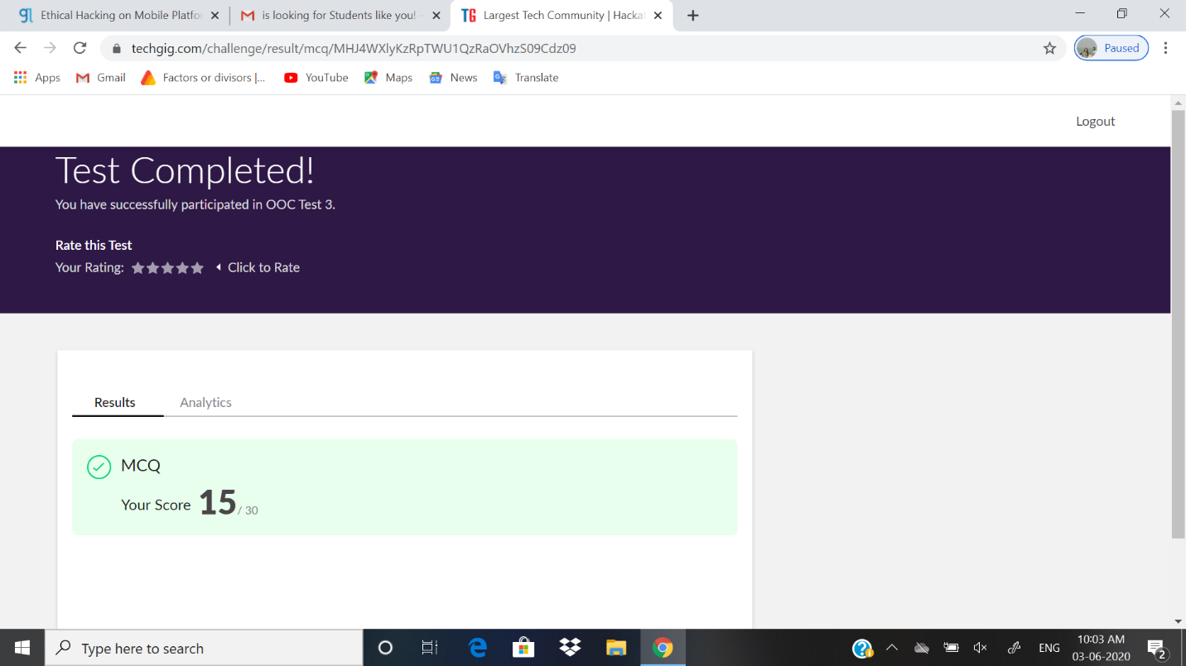

Certification Course Details: In January 2015, the Cloud Foundry Foundation was created as an independent not-for-profit 501(c)(6) [Linux Foundation](https://en.wikipedia.org/wiki/Linux_Foundation) Collaborative Project.[[11]](https://en.wikipedia.org/wiki/Cloud_Foundry#cite_note-11)

Following the creation of the Cloud Foundry Foundation, the Cloud Foundry software (source code and all associated trademarks) was transferred to be held by the open source software foundation. It is primarily written in [Ruby](https://en.wikipedia.org/wiki/Ruby_(programming_language)), [Go](https://en.wikipedia.org/wiki/Golang) and [Java](https://en.wikipedia.org/wiki/Java_(programming_language)).[[12]](https://en.wikipedia.org/wiki/Cloud_Foundry#cite_note-12)

As of February 2019, the Foundation had 65 members.[[13]](https://en.wikipedia.org/wiki/Cloud_Foundry#cite_note-13)

The foundation serves as a neutral party holding all Cloud Foundry [intellectual property](https://en.wikipedia.org/wiki/Intellectual_property). Once intellectual property is contributed to Cloud Foundry, it becomes property of the Foundation and these assets cannot be transferred to for-profit entities, as per the laws governing 501(c)(6) organizations. The Foundation holds two contributed types of intellectual property: trademarks and a copyright on the [collective work](https://en.wikipedia.org/wiki/Collective_work) of the community. It also has a license to use and re-license all code contributions, but does not own copyright on those contributions.

**SNAPSHOT:**

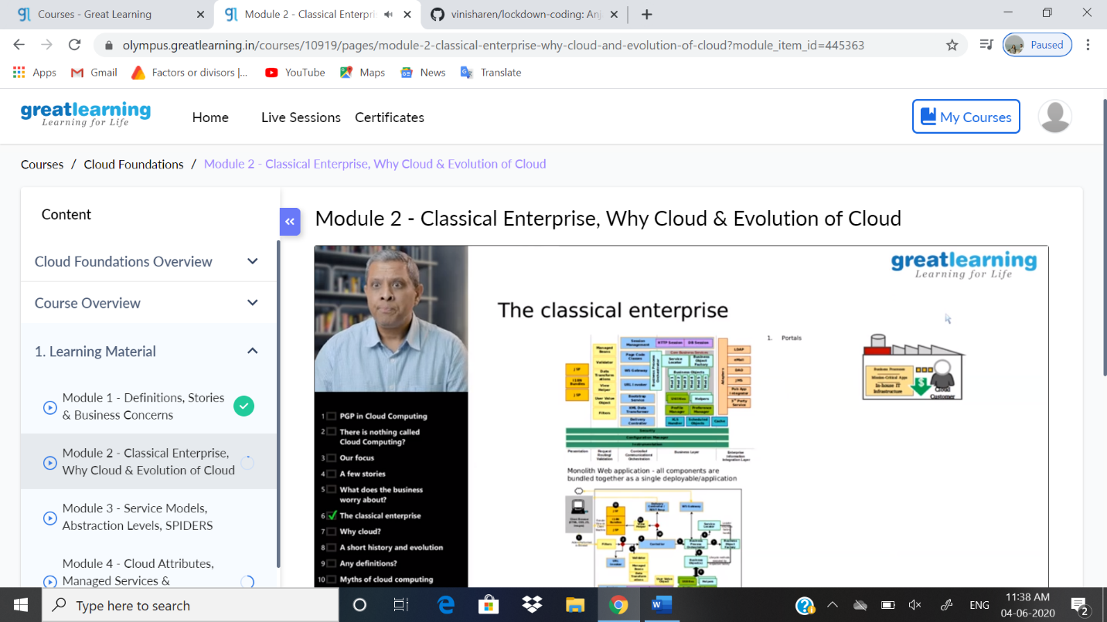

ONLINE CODING DETAILS:

PROBLEM 1: **Write a code segment in java to swap two numbers using call by object reference**

SNAPSHOT: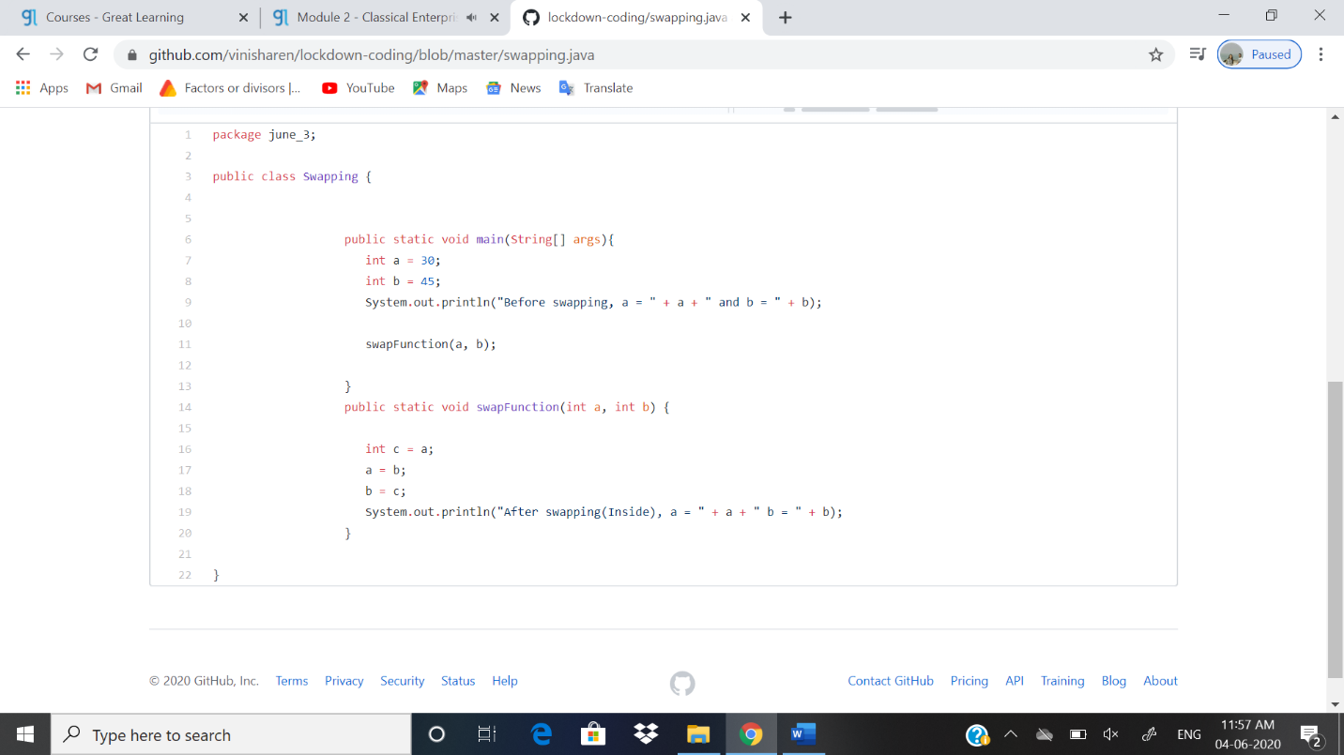

PROBLEM 2: **Write a java program to find last digit of a ̂ b (a to the power b) for large number**

SNAPSHOT: 